ASSESSMENT 5

*“EQUI & NON EQUI JOINS, SUB-QUERY, NESTED QUERY”*



Submitted By

VAIBHAV PATIDAR

IPS ACADEMY, INDORE (M.P.)

**Date :** 08-12-2023

**Week 1** | **Day - 05**

**EQUI JOINS :** Will give the data which follows condition

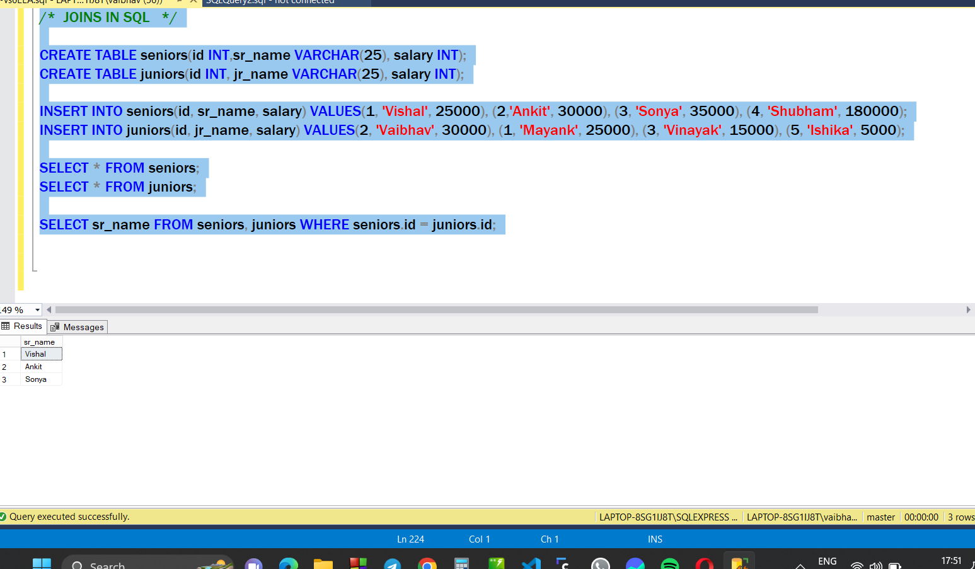

**NON-EQUI JOINS :** Will return the data not following condition

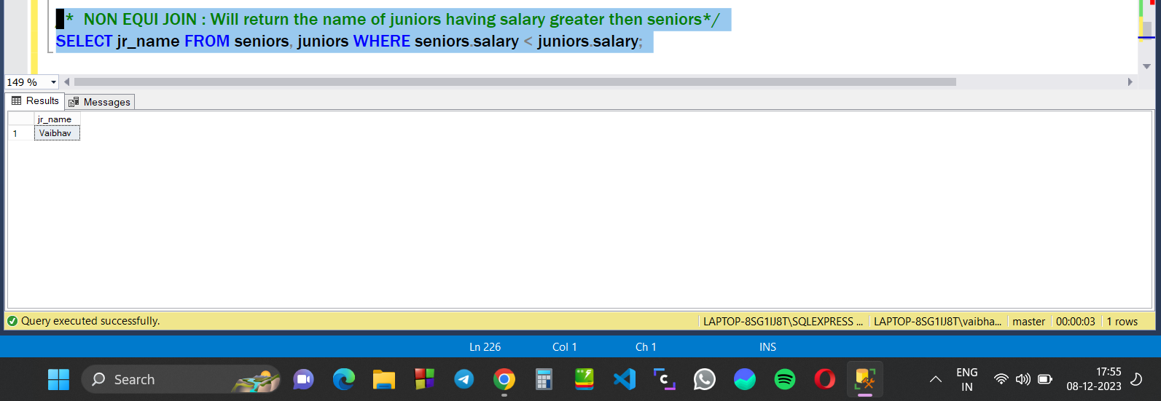

**SQL Sub Quesries & Nested Queries :**

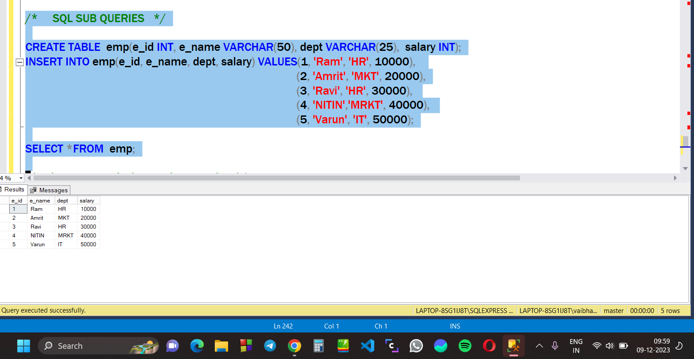

**Sub Query 1 : Display Maximum salary from the table.**

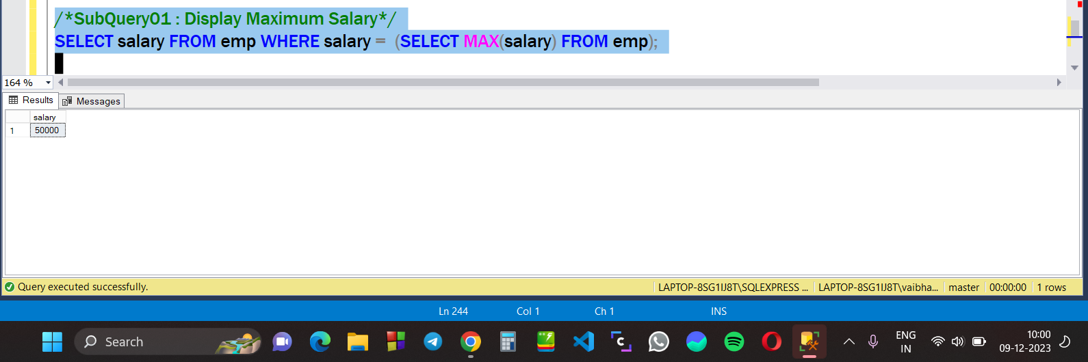

**Sub Query 2 : Display name of person taking maximum salary**

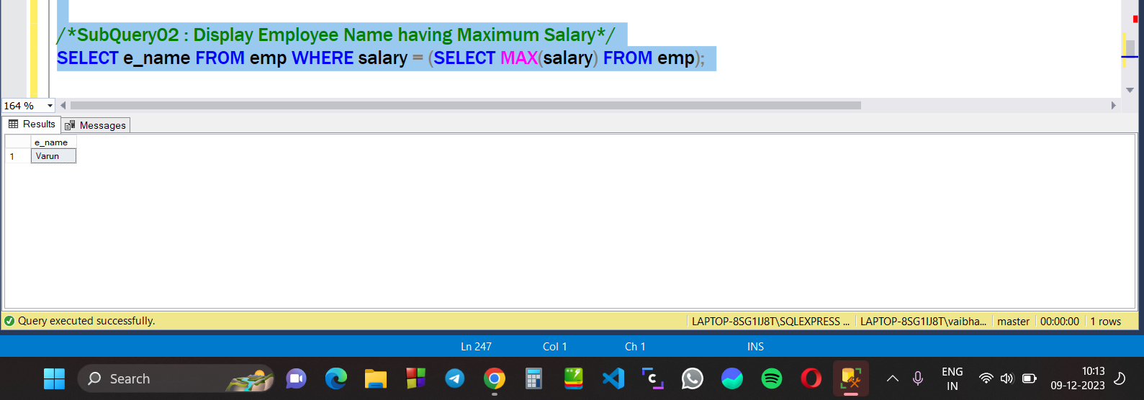

**Sub Query 3 : Display second highest salary from emp**

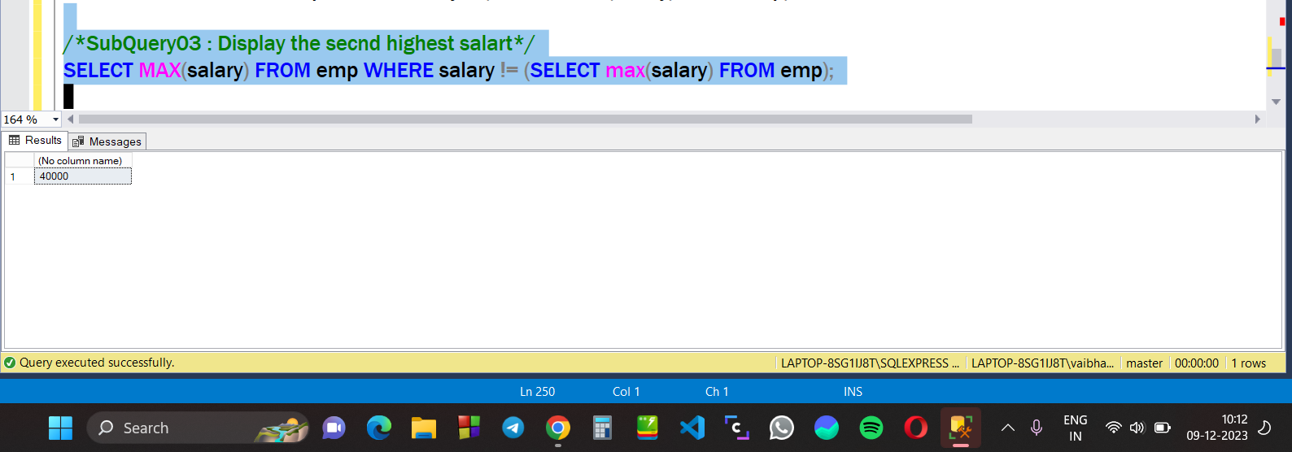

**Nested & Sub Query 4 : Display name of employee taking 2nd highest salary.**

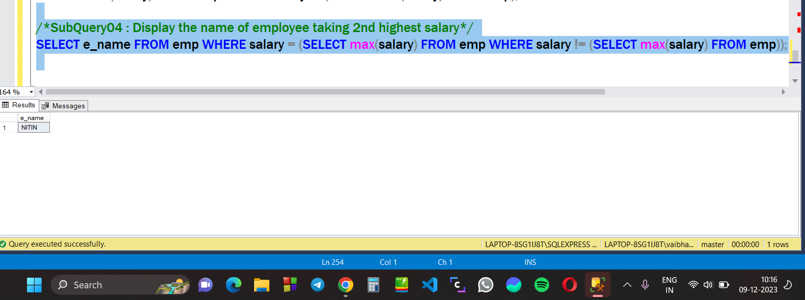

**Sub Query 5 : Group the department and show count of department using GROUP BY**

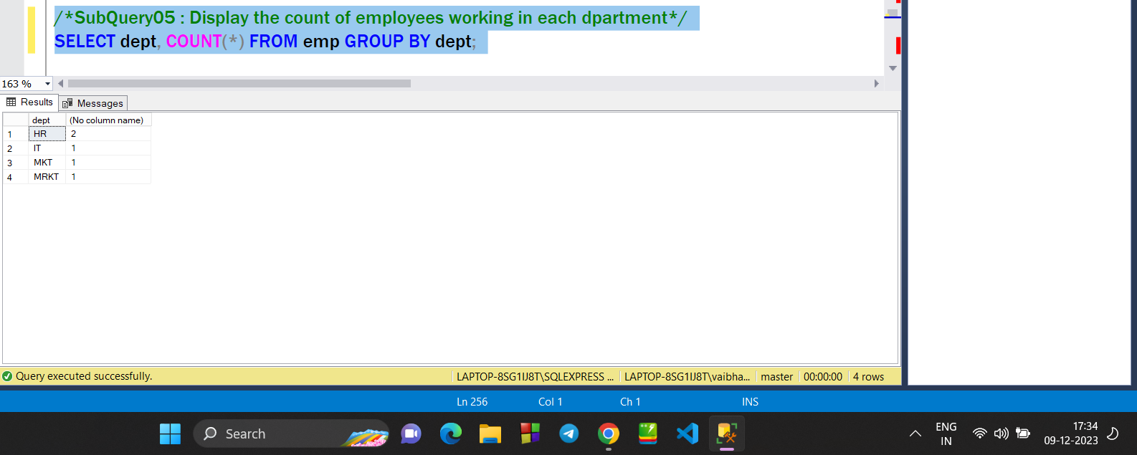

**Sub Query 6 : Display the name of the department HAVING less then 2 employee.**

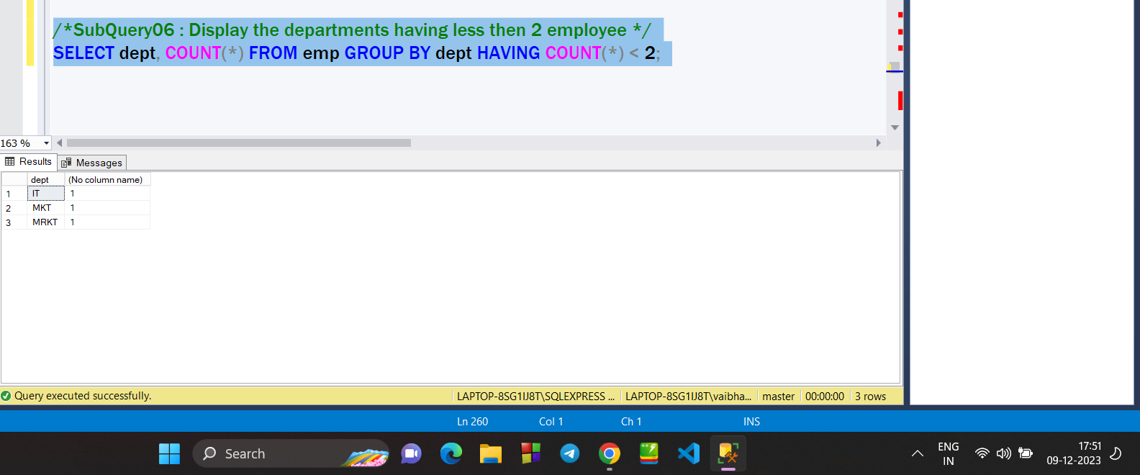

**Sub Query 7 : Display the name of employee having maximum salary in each department.**

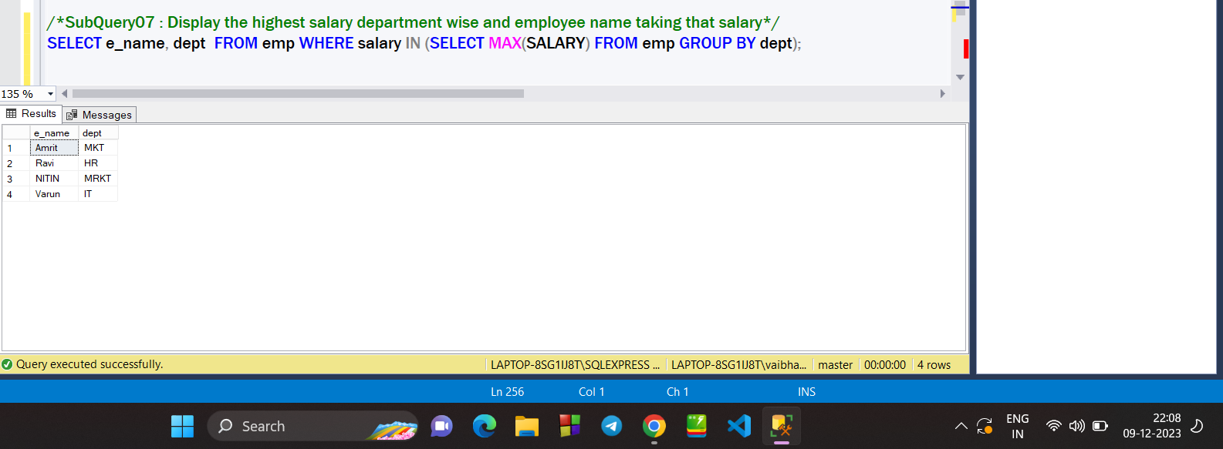

**Sub Query 8 : Display detail of employee belongs to ‘Delhi’ OR ‘Chd’ OR ‘Pune’ using IN command**

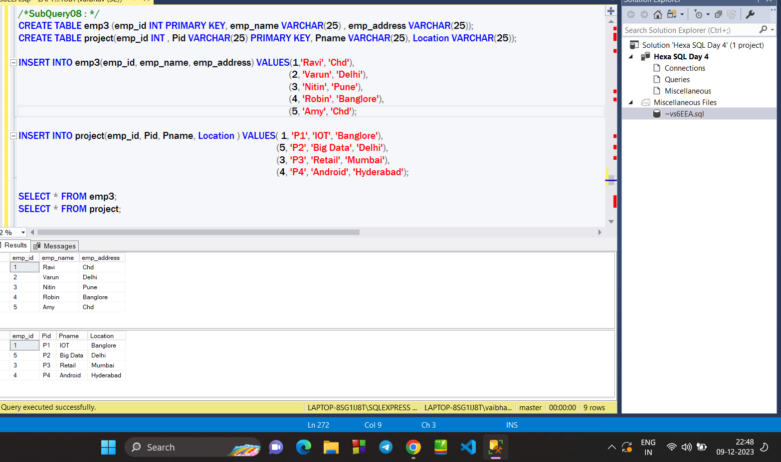

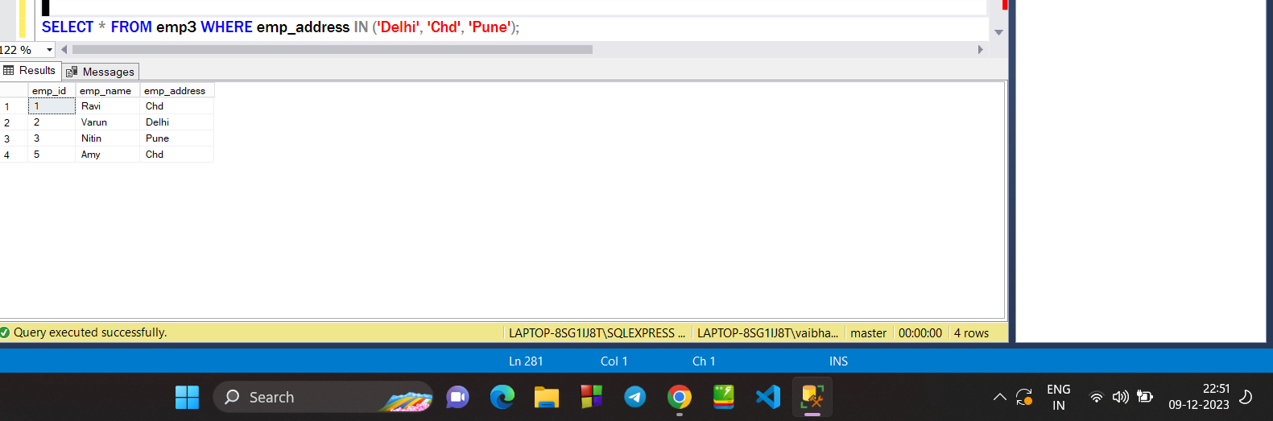

**Sub Query 09 : Display the info of Employee which not belong to ‘Chd’ & ‘Banglore’ using NOT IN command**

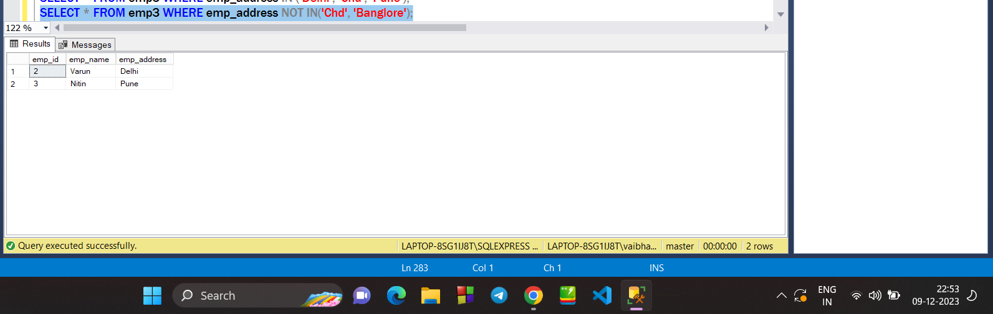

**CORELATED SUB QUERY (using EXISTS, Not Exists, ) :**

**Using Exists : Display all the info of employee assigned a project.**

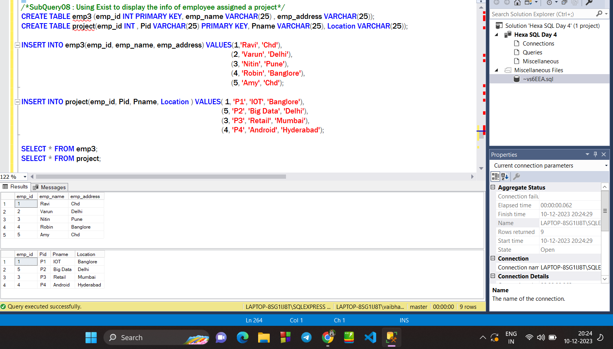

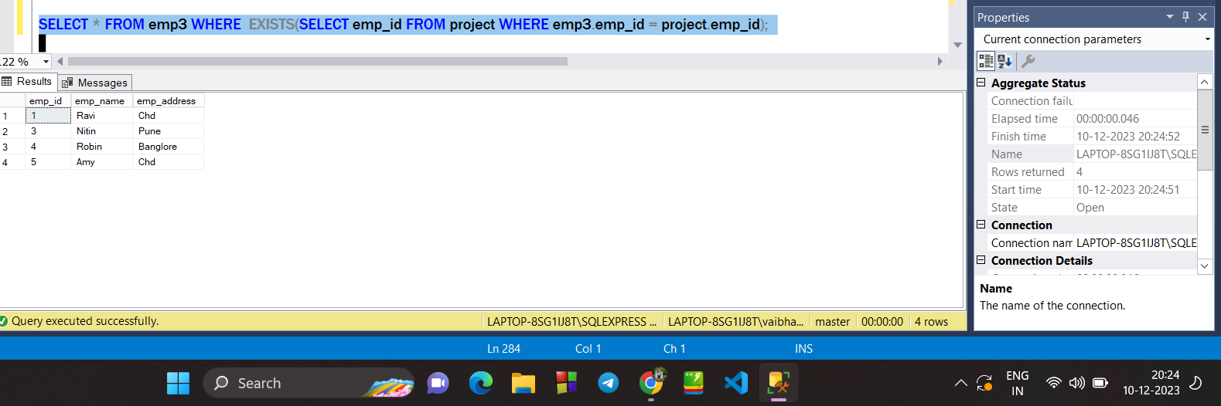

**NOT EXISTS : Display the info of employee who has not assigned a project.**

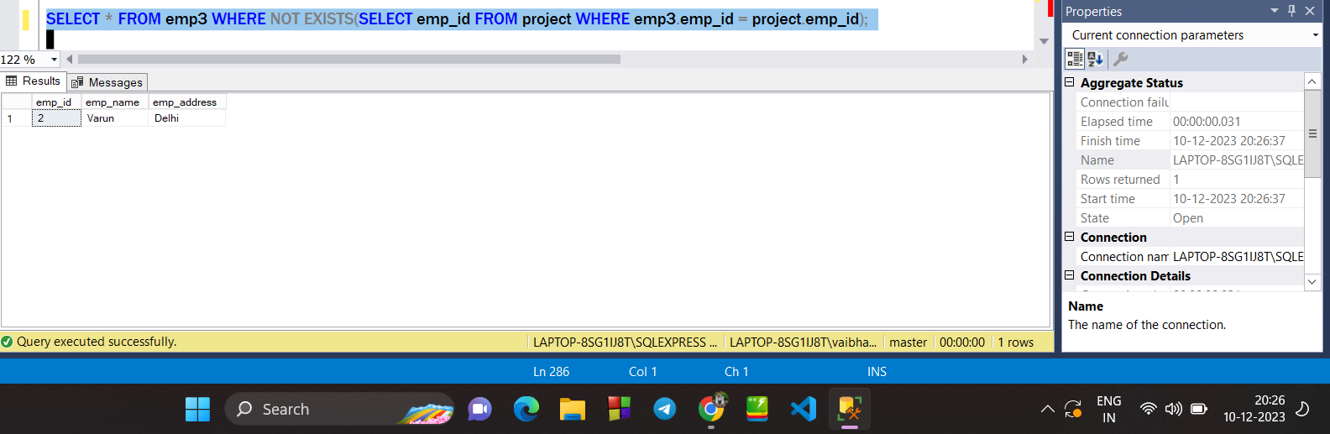

**GROUP BY & ORDER BY :**

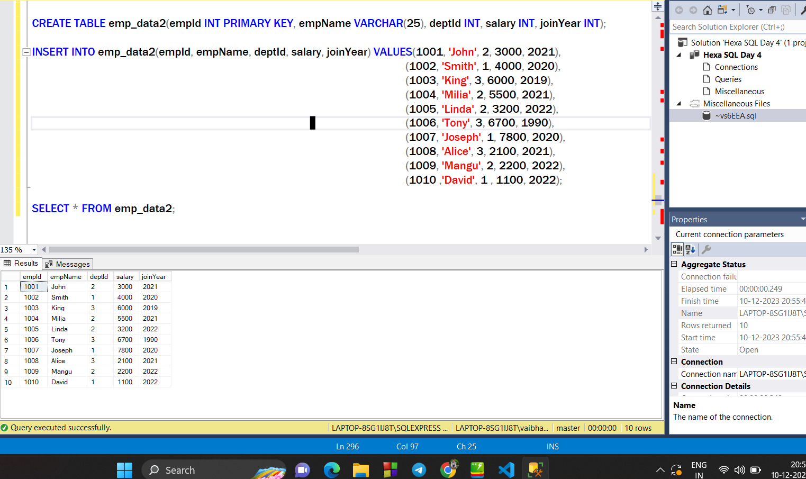

**Query 1 : Find Maximum salary department wise using GROUP BY**

